**Open Ended Experiment**

Of

**Basic Simulation Lab**

Submitted To: - Mrs. Nidhi Gaur

Submitted By: - Achintya, Harsh, Vivek, Ritika

Enrollment No.: - A2305220450

Batch: - 3CSE -4X

Session: - 2020-24

**Aim: -** a)Read an Audio file and playback.

b) Speed up and Slow down an audio signal during playback.

**Tool Used: -** GNU Octave

**Theory: -** MATLAB/Octave provides audioread command to read any audio file in .mp3, .wav, .flac, .aac, etc. forms. The most basic form of audioread command to read an audio file is:

audioread(“sample.ogg”)

where sample.ogg is an audio file in .ogg format. The above command line stores the audio file into variable y and the sampling frequency in variable Fs.

To vary the speed of the audio track and volume, we directly use the variables as speed and volume respectively.

Further, we use stretchaudio command to apply speedup or slow down factor, so that, the sample rate of audio file remains same, but duration of signal could increase or decrease.   
To play an audio file in MATLAB we use the sound() function. The function plays the sound. If the Fs variable is not defined or included in the command, it will assume the default sample rate of 8192 Hz.

sound(y, Fs);

audioplayer(y, Fs) returns a handle to an audio player object. After creating audio player object, we can use different methods such as stop(y) to stop playback, pause(y) to pause playback, resume(y) to restart playback from where it was paused, etc.

**Code:**

**a) Read An Audio File And Playback.**

[y,fs]= audioread('sample2.ogg');

speed= fs;

%time domain

t= linspace(0,length(y)/speed, length(y));

figure;

plot(t,y);

title('Audio Graph')

xlabel('time')

ylabel('amplitude')

sound(y,speed);

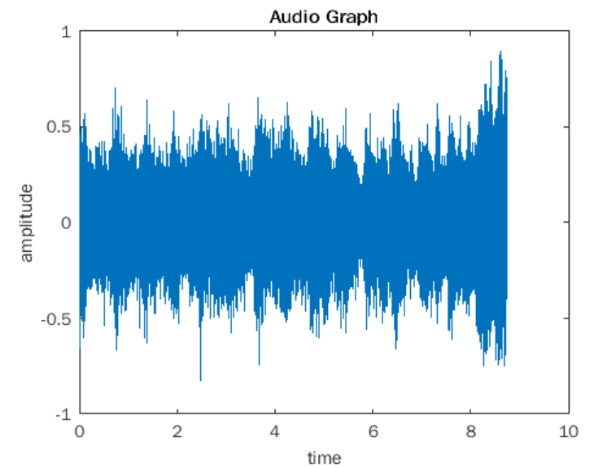

**b) Speed Up And Slow Down An Audio Signal Playback.**

* Speed Up

[y,fs]= audioread('sample2.ogg');

%increasing speed to 2X

speed= 2*fs;

%time domain

t= linspace(0,length(y)/speed, length(y));

figure;

plot(t,y);

title('Audio Graph')

xlabel('time')

ylabel('amplitude')

sound(y,speed);

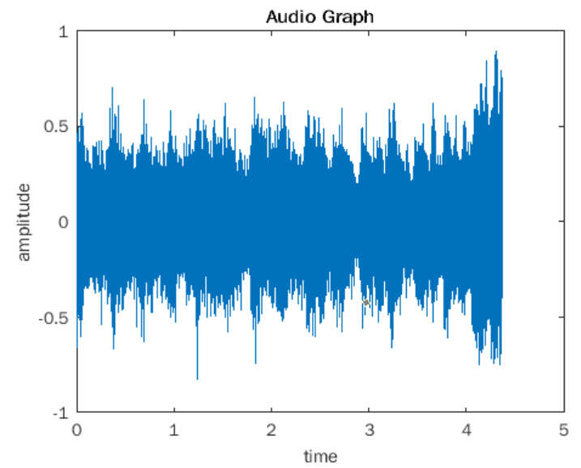

* Slow Down

[y,fs]= audioread('sample2.ogg');

%decreasing speed to 0.5X

speed= 1/2*fs;

%time domain

t= linspace(0,length(y)/speed, length(y));

figure;

plot(t,y);

title('Audio Graph')

xlabel('time')

ylabel('amplitude')

sound(y,speed);

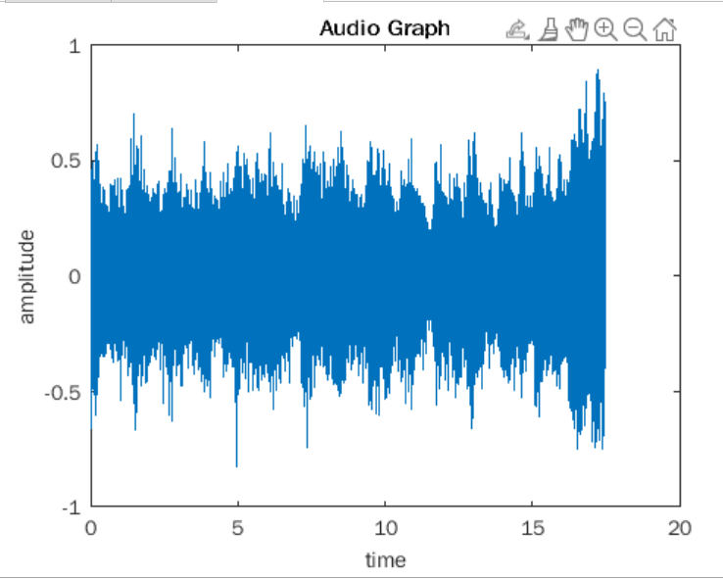

**Full code to dynamically change the sound speed**

file = 'MF Doom - Rapp Snitch Knishes [Instrumental].ogg';

file2 = 'JonTron Original Theme - Seamless 10 Minute Extended Loop.ogg';

[M, fs] = audioread(file);

player = audioplayer (M, fs);

play(player);

while (isplaying(player))

speed = input('Enter Speed');

if (speed != 0)

values = get(player);

value = values.CurrentSample;

disp(value);

player = audioplayer(M, fs*speed);

play(player, value);

else

pause(player);

break;

endif

endwhile

#infinite loop

display('Player Paused, BYE');

**Result:**

The audio file has been successfully read and the speed has been increased and decreased.